Orchard Valley United Church
130 Cornwallis Ave., New Minas, NS B4N 3M7
Contact: (902) 681-0366
admin@orchardvalleyunited.ca
Announcements for
Sunday, Sept 27th, 2026
10am Worship Service
Welcome all who worship with us! We’re happy to be together. Thank you to the following people for their participation in Worship and in the ongoing work of OVUC:
Worship Leader………………………………Rev. Dr. Linda Marcotte
Choir Director……………………….……………..Thea Koenig-Burton
Accompanist………………………..……… Carmen Peng, Ari Snyder
Anthem……………………….. Orchard Valley United Church Choir
Scripture Readings………………............................ Linda Barkhouse
Mission & Service…………………………... Shelley Moore-Dunfield
Live Stream Team………………….. Mary Cormier, Gary Dunfield
Sylvia Jacquard, Andrea Purvis, Gordon Wray
Hospitality……………………………. Jennie Bustin, Jane McDonald
Jean Millet, Linda Swindells
Greeters……………… Mindy Vinqvist-Tymchuk, Joy Waterbury
Tellers…………………………………… Brenda Crozsman, Helen Gill
Many thanks to all those who contributed to Worship Service at OVUC today!
Livestream: Live stream will not be available during the 10am service due to connectivity challenges but the service will be on YouTube later in the day!
Please check out our website for online Worship Services and much more! www.orchardvalleyunited.ca
Admin Office hours: Mon-Thurs, 8am-12noon (902-681-0366 ext. 1)
Rev. Linda: by appointment (450-522-3005)
~All Church offices are closed on Fridays~

Sept 25 | Fri | All day  8:30am | - OVUC Offices closed  - Women’s Breakfast
Sept 26 | Sat | 8pm | - Narcotics Anonymous
Sept 27 | Sun | 10am | - OVUC Worship Service moved to Covenanter Church, Grand Pre – Orange Shirt Day! NO SERVICE at OVUC**
Sept 28 | Mon | 10:30am  7pm | - Spirit Yoga with Joy!  - Council Meeting
Sept 30 | Wed | All day  1-3pm | - OVUC Offices Closed – National Day for Truth and Reconciliation  - Centre 130
Oct 01 | Thurs | 10am  1pm  7pm | - Hope New Minas Al-Anon Family Group  - Games Social  - Choir Rehearsal
Oct 02 | Fri | All day  8:30am | - OVUC Offices closed  - Women’s Breakfast
Oct 03 | Sat | 8pm | - Narcotics Anonymous
Oct 04 | Sun | 10am | - Sunday School  - Worship Service

Let’s help others by being scent-free so everyone feels free to attend, work at, or just visit our beautiful Church!!
Direct Deposit ETRANSFER EMAIL:
Please use: treasurer@orchardvalleyunited.ca
Please note: Announcements that you wish to go in the bulletin are needed no later than Tuesday at 12-noon every week. If you miss the deadline, they will be included in the next week’s announcements. Thanks!

Our OVUC Worship Service moved to Covenanter Church on Sunday, September 27th! (No service at OVUC) Worship will begin at 10am with a 15-minute hymn sing.
Please consider wearing the colour orange for Orange Shirt Day. Lemonade and cookies will be offered after service.
Live stream will not be available during the 10am service due to connectivity challenges but the service will be on YouTube later in the day. All are welcome!
Outdoor bathroom facilities and a parking attendant will be on site!

Volunteer Pianist Needed: If you play the piano and enjoy visiting with seniors, please consider helping with Orchard Valley's worship services at 4 local seniors' residences. Worship services are once a month at each location and fall on either a Wednesday or Thursday morning. Each worship is only a half-hour and usually involves just 4 to 5 well-known hymns. Music provided. You would be joining 3 other pianists already committed to helping. If interested or you need more information, please contact Andy Pitter (andriel_p@yahoo.ca or 902-542-1545).

Committee Member Needed: Andy Pitter is doing a Field Placement with Orchard Valley for the Centre for Christian Studies' Certificate in Christian Education and Worship. She is required to form a local learning committee who will meet about once a month with her over the year to discuss her placement. She just needs one more committee member. If you would be interested and willing to serve this way, please contact her (andriel_p@yahoo.ca or 902-542-1545).

Trivia Night at Orchard Valley United Church – Friday, Oct 2nd at 7pm. Open to all individuals and families. Come have some fun and test your knowledge. All for a good cause, the Refugee Resettlement project. (Freewill donation)

Autumn Canucopia Food Bank Drive – Orchard Valley is holding its Autumn Canucopia Food Bank Drive on Saturday, October 3, at Atlantic Superstore in New Minas from 9 am to 5 pm. There is a chart on which volunteers can sign up for 1-hour slots to give out flyers/collect food/wheel grocery carts of food over to our location. Please sign up by Sunday, Sept. 27. All food items and money raised will be divided between our three local food banks – Canning, Fundy (serving Kentville/New Minas) & Wolfville. Please give your time to support this worthy cause.

The Glooscap Breakfast Program team needs some new members. This Outreach project provides two people each morning for a week to make toast for students who come to the lunchroom. We provide this service from 7:15 - 8:15 a.m. 4 times each year. This project is a good match for earlybirds who like kids, particularly those who live on the north side of the Cornwallis River. Each volunteer would work 1-2 days per week depending on the number of volunteers that we have.

Women’s Friday Morning Breakfast is back! Fridays at 8:30am – freewill offering.

Spirit Yoga Group has started! Mondays from 10:30 a.m. to 11:30 a.m. A fee of $3 to $5 is recommended. Bring a yoga mat, block, strap, blanket/throw and water bottle. A reminder that if school is cancelled for some reason, this yoga practice is also cancelled. Hope to see you there!

Coffee Time: September is here! Coffee time is offered following the service. We would love to see you and welcome you to linger after Worship and catch up with each other!

Red Scarf Project - We are once again participating in the Red Scarf project led by AIDS NS. All red scarves should be completed by mid November to be delivered for the Dec. 1 display on the fence of the Public Gardens. 6” by 60” long in red. Please leave in the basket in the flex space.

Men’s Group Fundscrip Orders:
Sunday, Sept 27 – Orders submitted
Sunday, Oct 04 – Orders delivered
Sunday, Oct 11 – Orders submitted
Please contact one of the following men for an order form - Cecil White, Tim Warmington & Ian Godfrey
Subscribe to OVUC’s YouTube Channel – Did you know we have a YouTube Channel? Simply select the ‘Subscribe’ button the next time you are watching one of our videos or during the Live Streamed Worship Service. (Please note that you must have a Google account in order to subscribe.) https://www.youtube.com/channel/UCEW4VOpk_znrA5qevOqCr9Q
Video Recorded Worship Services – Please view our weekly posted video recorded services by going to our webpage and clicking on “Worship Services/Video Recorded Messages”.

Community Events
NA Meetings – Narcotics Anonymous will be holding meetings each week at OVUC: Saturdays at 8pm. For more info, please visit: https://carna.ca or 1-902-789-8323
Hope New Minas Al-Anon Family Group – Hope Al-Anon is a fellowship that offers help and hope for families and friends of alcoholics. The group meets at OVUC on Thursdays, 10-11am and can also be accessed by using FONGO for phone meetings. To enter the meeting, call 1-902-932-1200 and enter 902-932-7986#. For more information about Al-Anon visit www.al-anonmaritimes.ca or Al-Anon World Service Office at al-anon.org.
Hello Friends of VCLA,
We’re reaching out to ask for a little help with Picnic with Purpose as we head into the final week of sales.
We’ve put together a lovely fundraiser—a handcrafted picnic for two featuring great food from the VCLA kitchen and gardens, local ingredients and Benjamin Bridge alcohol-free piquettes. Funds raised will provide much-needed flexible support for our kitchen, gardens, meals, welcoming spaces and other parts of VCLA that don’t always fit neatly within program funding.
Picnic with Purpose is more than a fundraiser for us. We’re raising flexible, unrestricted funds. Those dollars help us put food on the table through our community kitchen and meals, grow and share food from our gardens, create welcoming spaces where people can connect and belong, and respond to the practical needs that can make the difference between someone being able to participate in learning—or not.
Each Picnic with Purpose is a handcrafted picnic for two, featuring food from the VCLA kitchen and gardens, local ingredients, Benjamin Bridge alcohol-free piquettes and a few special extras.
📍 October 2 — VCLA Oakdene Community Hub, Kentville
🍇 October 3 — Benjamin Bridge, Gaspereau Valley
Orders close September 30.
👉 Order or learn more: https://vcla.ca/picnic-with-purpose/
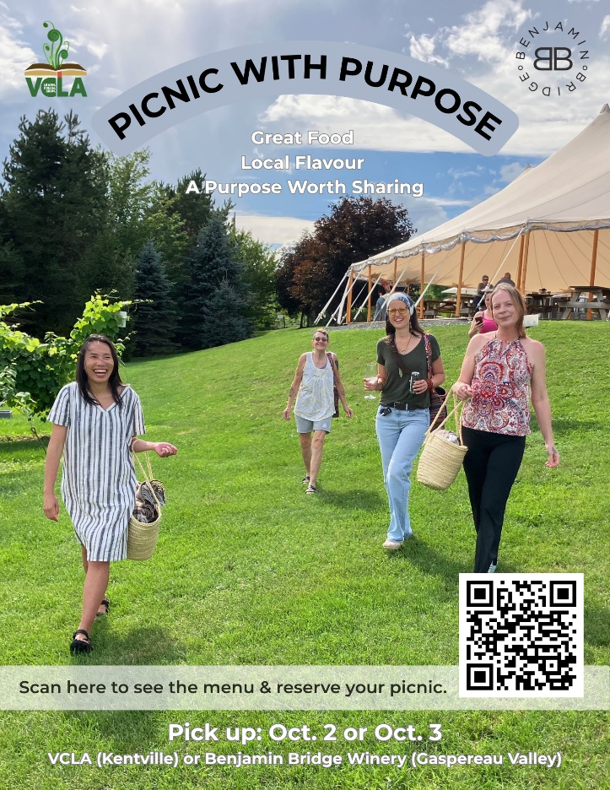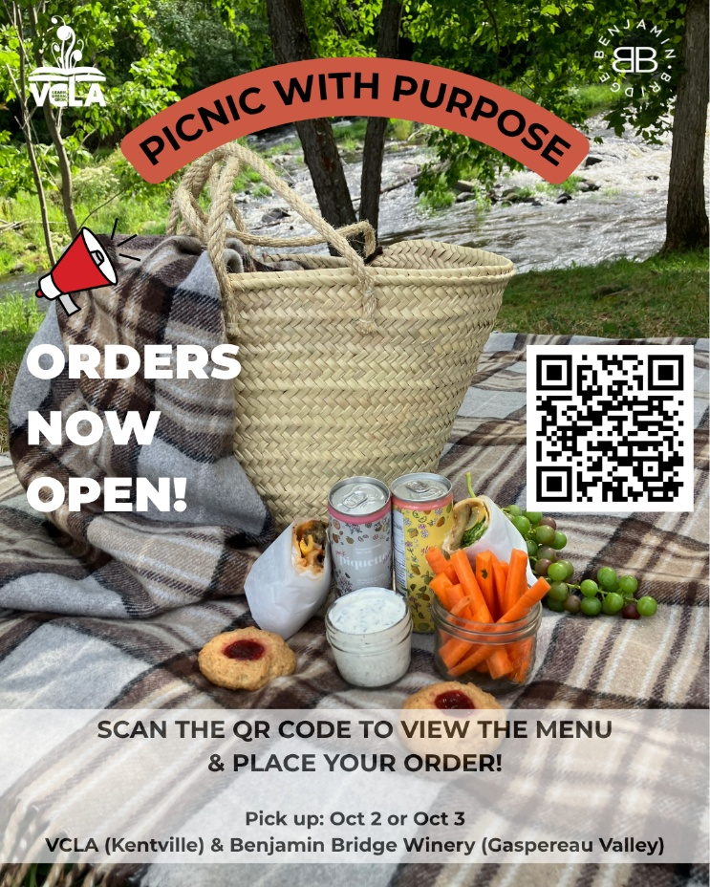

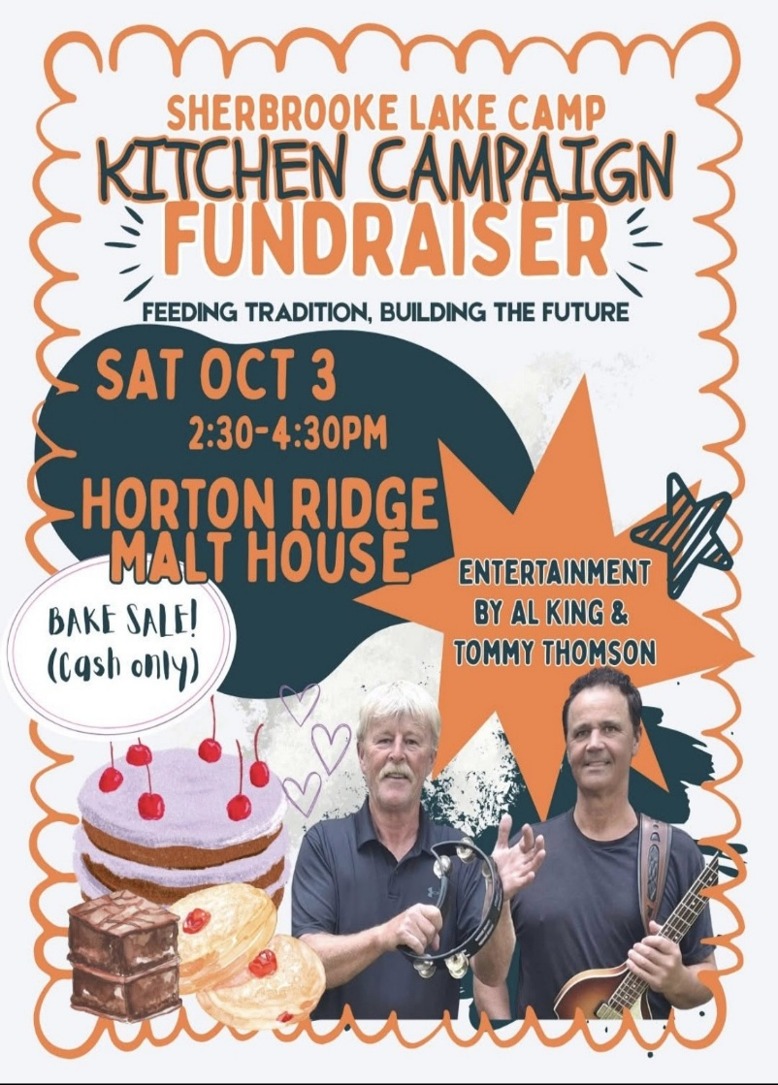
We’re excited to share an upcoming fundraiser in support of Sherbrooke Lake Camp’s Kitchen Campaign! 🎉
Join us on Saturday, October 3 from 2:30–4:30 PM at Horton Ridge Malt House at 2504 Ridge Rd, Wolfville for a fun afternoon featuring:
🍪 Bake Sale – Cash only!
🎶 Live entertainment by AL King & Tommy Thompson
👨‍👩‍👧‍👦 Kids, families, and dance moves are welcome!
❤️
Supporting the future of Sherbrooke Lake Camp’s kitchen.
Our kitchen is such an important part of camp life, helping us feed campers and staff while creating many of the traditions and memories that make camp so special. This fundraiser will help us continue working toward our kitchen campaign and the future of camp.
We would love to see our camp families there! Bring a friend, enjoy some entertainment, grab a baked treat, and help support Sherbrooke Lake Camp.
Can’t make it? You can still support our Kitchen Campaign! Every bit helps us get one step closer to building a kitchen that will serve generations of campers to come. You can make a donation or learn more about the campaign here: Sherbrooke Lake Camp Kitchen Campaign

Old Time Gospel Hymn Sing-Along!
All are welcome to attend our "Old Time Gospel Hymn Sing-along” at Wickwire Place Retirement Living Residence, 30 Wickwire Av., Wolfville. These are hymns you haven't sung since Sunday School and Church as a kid - but you know them all.
Pianist and leader is Nancy Denton-Peck. Singing starts at 7PM and ends at 8PM. Coffee, tea and treats are served.
This Sing-along happens on the third Wednesday of every month. If you have questions, please contact Scott Sweatman at 902-697-2212.
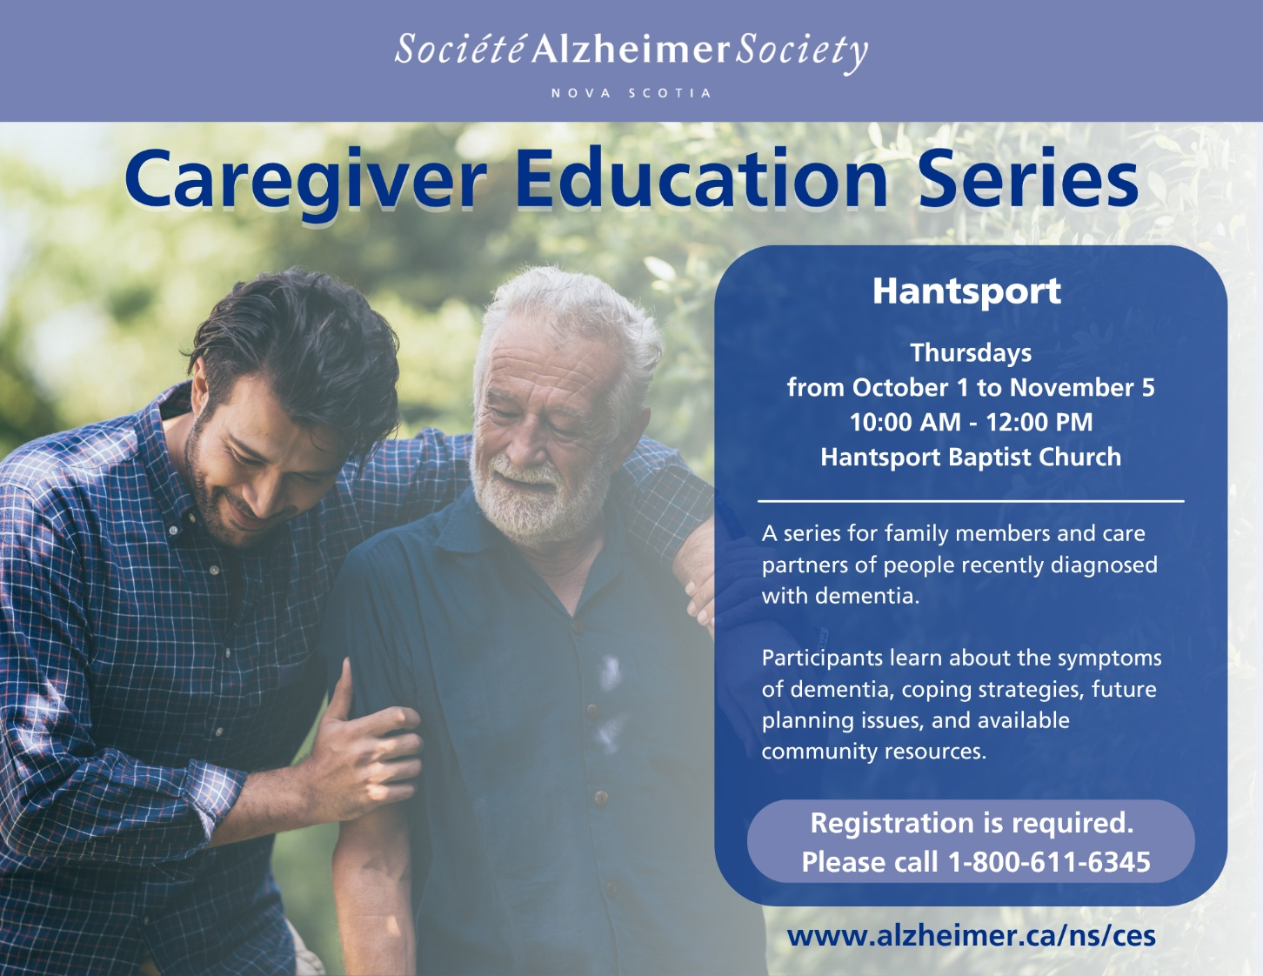

KINGS SENIORS’ SAFETY SOCIETY PROUDLY PRESENTS LIVING ALONE ACADEMY
LIVING ALONE is a four week program that will offer practical skills, emotional support and helpful information to assist the older adult experiencing major life transitions. The academy is designed to help you prepare for living on your own – either through divorce, separation or the death of a loved one.
Topics include:
Grief and Loss, Grief Library,
Valley Waste Management
Rightsizing your Home, Safe Meds
Tenancy Rights and Info, Falls Prevention
Seniors’ Tool Box
The sessions will be held at
Orchard Valley United Church, 130 Cornwallis St., New Minas
Wednesdays, October 14, 21, 28, and November 4, 9:30am to noon
The program is FREE but you must register by calling
Trishe Colman at (902)670-0725 by October 9th
A light snack will be provided
NO SCENTS PLEASE


